

ITA0330-Mobile Computing

Name: T. Dharani Devi Reg no: 192425036

Slot: D Course Name:Mobile Computing

Experiment 1: Basic Cellular System Using Figma

Aim: -To create an interactive diagram illustrating the components of a basic cellular system using Figma.

Procedure
- Open Figma and create a new design file.
- Create rectangular boxes to represent the major components of a cellular system.
- Add text labels for Mobile Station, BTS (Base Transceiver Station), BSC (Base Station Controller), MTSO (Mobile Telephone Switching Office), PSTN (Public Switched Telephone Network), and Databases.
- Arrange the components in a horizontal sequence to represent the cellular communication system.
- Use arrows between the components to indicate the direction of communication and their connections.
- Connect the Databases component to the MTSO to show its association with network information and management.
- Adjust the alignment, spacing, colors, and text formatting to make the diagram clear and readable.
- Preview the design and verify that all components and connections are displayed correctly.

Output: 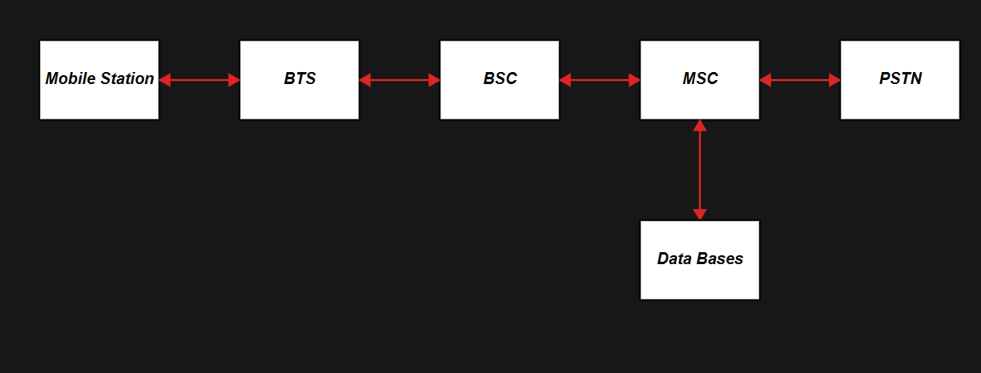

https://www.figma.com/make/l1kHBNPXksqugoF7edld8r/EXPERIMENT---1?p=f&t=22ypNhXdnr9dZSjN-0

Result: -Thus, an interactive diagram illustrating the components of a basic cellular system was created successfully using Figma. The diagram represents the connections between the Mobile Station, BTS, BSC, MTSO, PSTN, and Databases.

